

**SAFE STRIP**

**SAFE and green Sensor Technologies for self-explaining and forgiving Road Interactive aPplications**



**Grant Agreement Number: 723211**

**Internal Report: SAFE STRIP**

**Map requirements for applications**

## Document Control Sheet

|  |  |  |
| --- | --- | --- |
| **Document identity** | | |
| **Relevant WPs** | WP4 | |
| **Relevant Activities** | Applications | |
| **Authors** | | G.Valenti (UNITN) |
| **Status (D-draft; F-final)** | | D |
| **File Name** | | SAFE STRIP Map requirements for applications |
| **Dissemination Level** | | Confidential |

|  |  |  |  |
| --- | --- | --- | --- |
| **Version history table** | | | |
| **Version** | **Date** | **Modification reason** | **Modifier** |
| 0.1 | 18.09.18 | First version | G.Valenti UNITN |
|  |  |  |  |

## Purpose of the document

This internal report contains the requirements about the road geometry, morphology and elements required from the applications of WP4. It also provides general rules and a normative to follow on how to encode those data, in order to document how the messages about the data has to be sent.

## Legal Disclaimer

The information in this document is provided “as is”, and no guarantee or warranty is given that the information is fit for any particular purpose. The above referenced consortium members shall have no liability for damages of any kind including without limitation direct, special, indirect, or consequential damages that may result from the use of these materials subject to any liability which is mandatory due to applicable law. © 2017 by SAFE STRIP Consortium.

# Introduction

Most of the applications in Safestrip requires data on the geometry of the road and other elements, we refer to this kind of data as “Map data”. Map data are meant to be sent by the RSB to the Equipped vehicles or to the entity on which the application runs in case of Non-equipped vehicles. The approach is uniform for all the use cases (same conventions and Map message).

# General organization of the data and the messages

The data must be organized according to the regulation SAE J2735_201603 (It will be called the “Standard” for short), which provides precise indications on the data structure. The map data is described by the MSG_MapData data structure, which is the only data structure taken into consideration in this document.

# Map elements list

## Scenario objects:

Scenario is here defined as the complete map description within one use case. The standard provides for two types of scenario-like objects: intersections or road segments. The first is recommended, even if they are basically the same (same properties), they are intended to be extended in future versions of the standard. More than one of those objects can be used together to define a scenario.

## Map objects:

Once the scenario object is defined, the following elements must be represented. The elements message are listed below. This list is the minimum set of objects to be compulsory described in the map message, with all their properties (e.g. Lanes needs a direction). Objects are indicated on the use cases figures in Figure 1.

|  |  |  |  |
| --- | --- | --- | --- |
| Scenario element | Data Frame of  SAE J2735_201603 | Notes | Number on figure |
| Road lane | GenericLane |  | 1 |
| Sidewalk | GenericLane |  | 2 |
| Pedestrian crossing | GenericLane |  | 3 |
| Railway | GenericLane |  | 4 |
| Barrier (Roadworks or others) | GenericLane |  | 5 |
| Allowed lane (Roadworks) | GenericLane | Special lanes created when roadworks are present. They represents the paths allowed by the roadwork geometry (they can be represented or not on the road) | 6 |
| Median | GenericLane | Representing medians is significative if they are physical or double-lined | 7 |
| Parkings | GenericLane |  | 8 |
| Stop Lines | GenerciLane | Those elements in the SAE standard, have to be expressed as “end” of a road lane. | 9 |
| Bike lanes (if present in the VRU related cases) | GenericLane |  | - |
| Toll lanes and gates | GenericLanes | Equivalent to road lanes and stop lines | - |

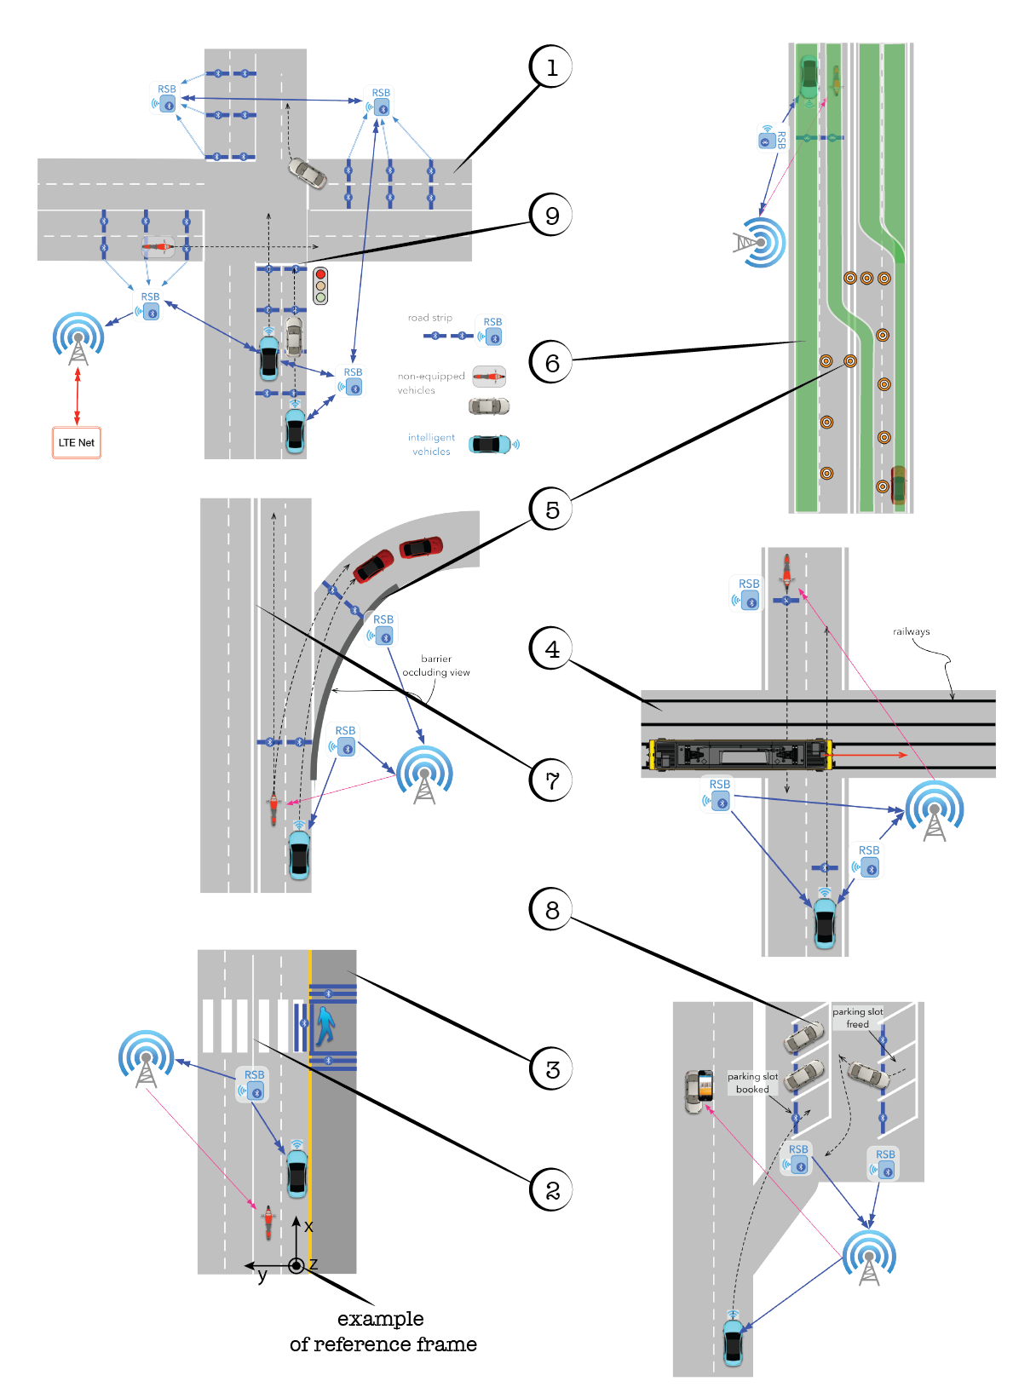

Figure 1: Objects to represent

# General rules:

## Area to represent

The area to represent must be related to the one the RSB units can cover with the signal transmission.

## Reference frame

All the elements in the scenario has to be represented in a common reference frame. A relative reference frame has to be used, the origin of the reference frame must be the starting point of a lane of type *vehicle* (see the Standard SAE J2735) at the boundary of the scenario, the x axis has to be parallel to the lane and the z axis has to be normal to the road plane at the origin. Coordinates in the relative reference frame must correspond to GPS coordinates in order to keep consistency. An example of reference frame is shown in Figure 1.

## Generic Lane

Most of the elements are expressed as “GenericLane”, the geometry of the lane is expressed point by point by the nodes’ position (in the relative reference frame). A Lane must end with a so-called “stop line” or a boundary of the scenario. Stop lines may correspond to specific allowed maneuvers. (It is all indicated in the standard).

The information on curvature is not stored in this data structure, for this reason the maximum distance between two nodes has to be selected taking into account the maximum curvature at those two nodes, following the rule $d_{ij}≪1/max⁡(γ_{i,}γ_{j,})$. Where *dij* is the distance between nodes, and γ is the curvature $γ=1/R$.

## Strips

The Map message does not provide data structures for the strips positions, anyway the strips position will be exchanged in another message, the reference frame must be consistent with the one in the Map message. Probably using the GPS coordinates when the strips are mounted.

# Open issues/proposals

## Roadworks mapping:

Barriers are meant to be expressed (according to the Standard) as GenericLane object. In case of the presence of roadworks two options are possible:

1. Another MAP message with a different Layer (Layer is a property of the map message) can be implemented, containing only the roadworks objects. This is to keep separated the static MAP implemented in the infrastructure, and a modular ad-hoc map for the roadworks case.
2. Roadworks related quantities can be implemented in the same Map message of the other quantities.

## Self-localization:

How the vehicle can receive the information about its location in the relative reference frame has to be decided. Gps improved by the strips’ vehicle detection can be a method.